Contents

How to create a Git Account 2

To create a new repository 2

To create a new branch 3

Make and commit changes 4

How to make and commit changes 4

Open a Pull Request 5

Merge your Pull Request 6

Setting up Git 6

Make a directory you want to store your local repository 7

Git Process workflow 8

Common used command in Git 8

# How to create a Git Account

1. To create a git account and become linked to the hpe repository click: [https://github.hpe.com](https://github.hpe.com/)
   1. Log into SMAL, and you will be automatically create a git account and links you to hpe
2. Install git token for HPE SMAL click here: <https://pages.github.hpe.com/GitHub/Support/Using%20HTTPS%20for%20push.html>

# To create a new repository

1. In the upper right corner, next to your avatar, click and then select **new repository**.
2. Name your repository hello-world.
3. Write a short description.
4. Select **initialize this repository with a README**.

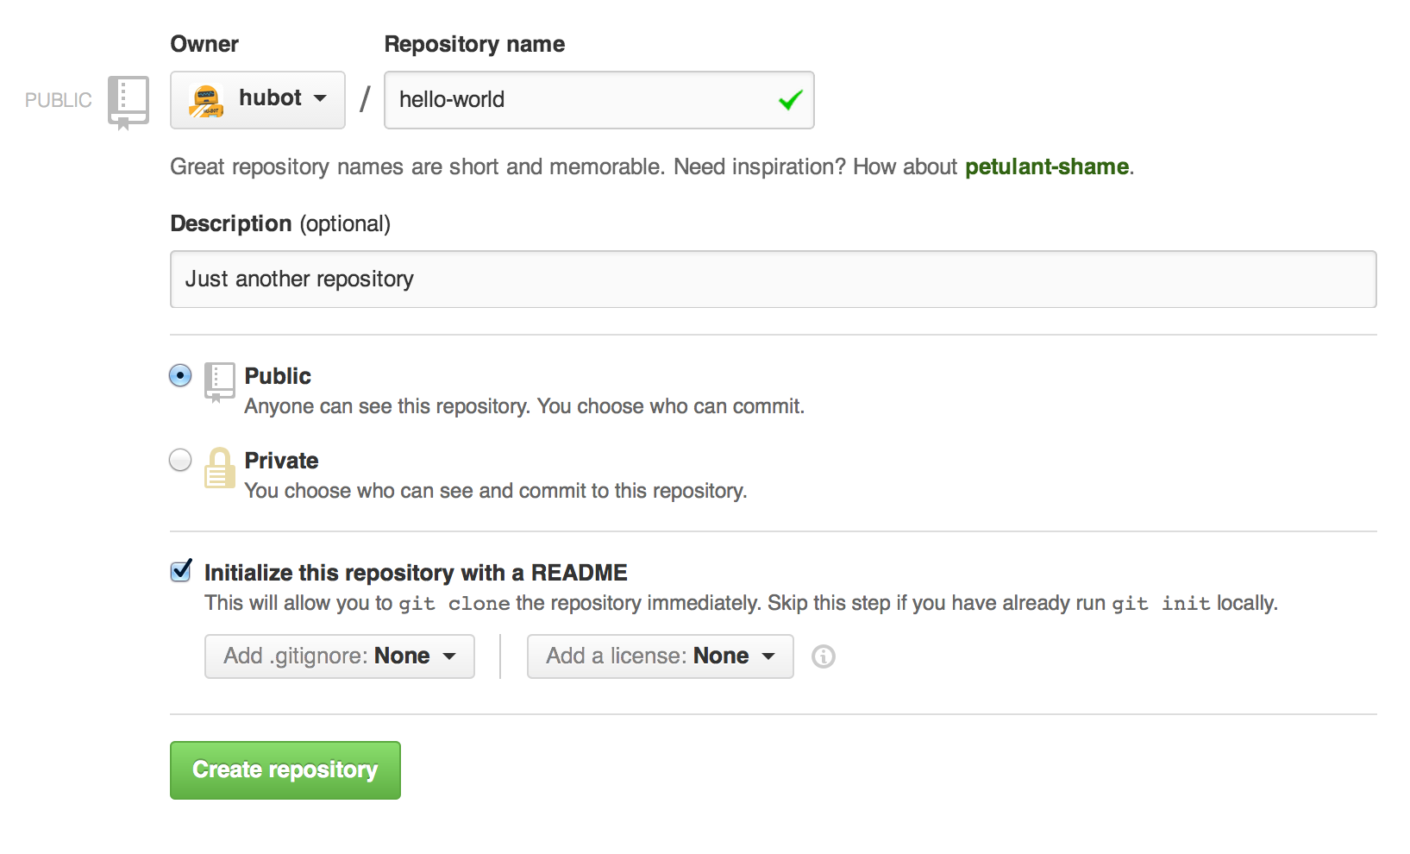

Click **Create repository**.

# To create a new branch

1. Go to your new repository.
2. Click the drop down at the top of the file list that says **branch: master**.
3. Type a branch name, into the new branch text box.
4. Select the blue **Create branch** box or hit “Enter” on your keyboard.

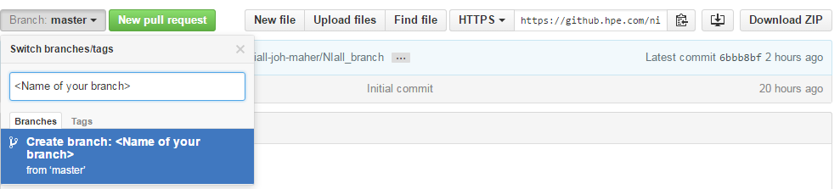

Now you have two branches, master and <your branch name>. They will look the same, until changes are made to either branches.

# Make and commit changes

On GitHub, saved changes are called ***commits***. Each commit has an associated ***commit message***, which is a description explaining why a particular change was made.

## How to make and commit changes

1. Click the file you want to edit or add comments.
2. Click the pencil icon in the upper right corner of the file view to edit.
3. In the editor, write a bit about yourself.
4. Write a commit message that describes your changes.
5. Click **Commit changes** button.

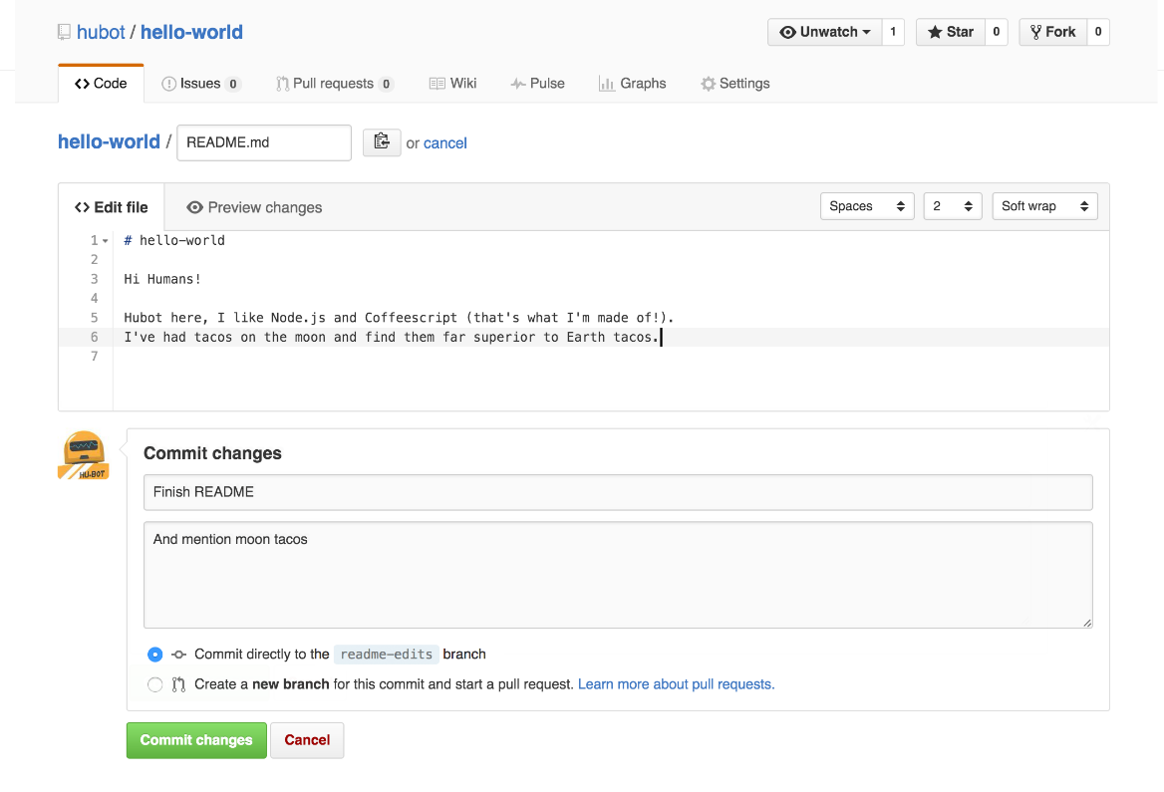

Now that the branch contains changes to the master, a push and merge request has to be send to the master

# Open a Pull Request

When you open a pull request, you’re proposing your changes and requesting that someone review and pull in your contribution and merge them into their branch. Pull requests show differences, of the content from both branches. The changes, additions, and subtractions are shown in green and red.

As soon as you make a commit, you can open a pull request and start a discussion, even before the code is finished.

You can even open pull requests in your own repository and merge them yourself.

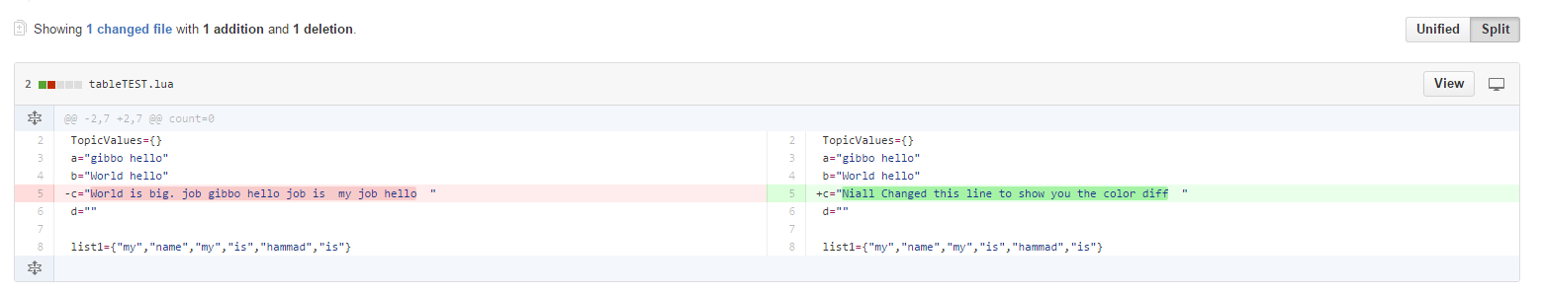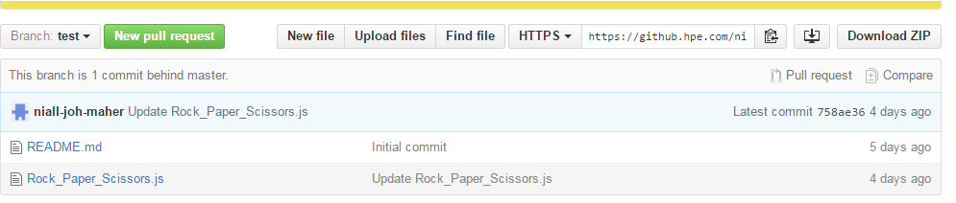

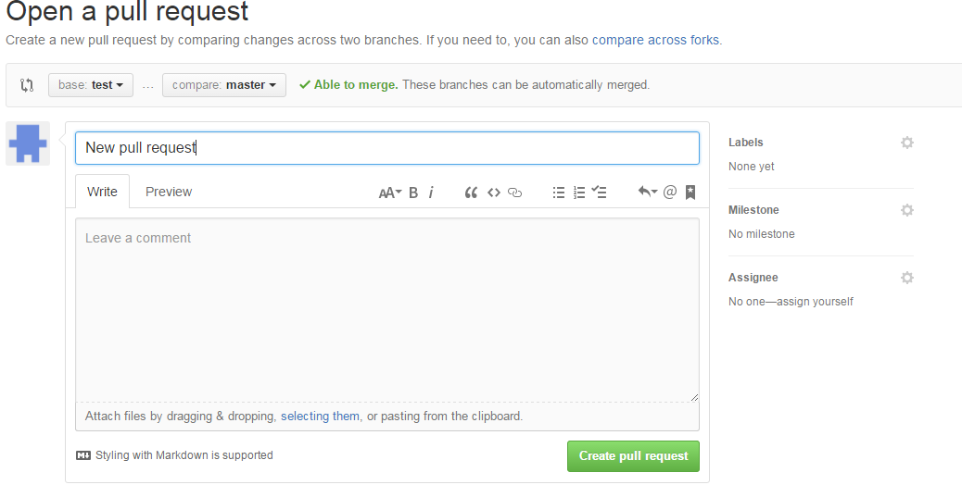

# Merge your Pull Request

In this final step, it’s time to bring your changes together – merging edits branch into the master branch.

1. Click the green **Merge pull request** button to merge the changes into master.
2. Click **Confirm merge**.
3. Go ahead and delete the branch, since its changes have been incorporated, with the **Delete branch** button in the purple box.

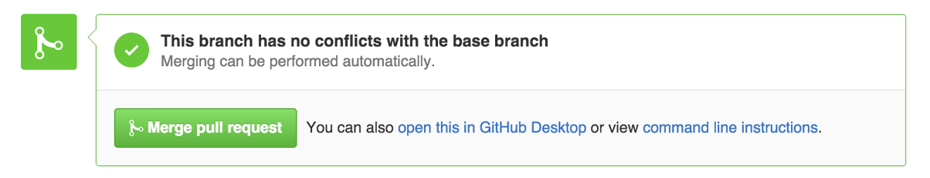

# Setting up Git

Download git bash shell form the following: <https://git-scm.com/download/win>

Open shell and add username and email

1. git config --global user.name "YOUR NAME"



1. git config --global user.email "YOUR EMAIL ADDRESS"



# Make a directory you want to store your local repository

1. If you’re creating a new repository
   1. Follow steps above but uncheck “Initialize this repository with README”

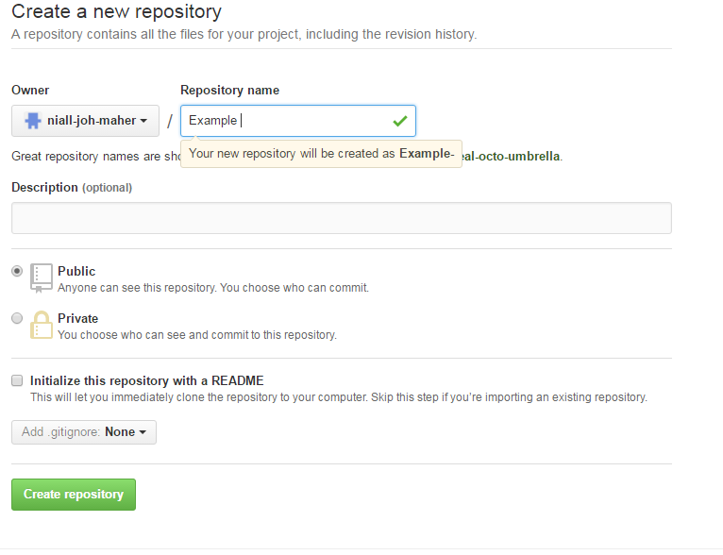

1. Open git bash and cd to directory (you want to use for your local repository)
2. git init (this initializes the directory you’re in)
3. git add README.md (all git repository have a readme file to tell people what the code does)
4. git commit -m "first commit"
5. git remote add origin <address>
6. git push -u origin master

# Git Process workflow

Changes will then be merged into master branch by repository owner

Discuss and review your code

Pull Request

Add changes and commit to master branch

Create your own branch of a project

Deploy your changes to master

# Common used command in Git

1. git clone <repository address> (clone the repository to your local machine)
2. git init (this initializes the directory you’re in)
3. git add README.md (all git repository have a readme file to tell people what the code does)
4. git commit -m "some commit" (this will commit the files you added)
5. git remote add origin <https://github.com/NiallMaher/test2.git> (this sets the connect to the intended repository)
6. git push -u origin master (pushes all local changes to the git repository)
7. git pull (source branch) (destination branch) (pull current version from github repository)
8. git config --list (Shows all variables in .git config file)
9. git remote –v (Shows connection to git repository)
10. git status (Show the working tree status)
11. git add ‘*.txt’ (adds all text files to staging area)
12. git log (Show commit logs)
13. git diff (Show changes between commits, commit and working tree, etc)
14. git diff head / git diff -- staged <http://tinyurl.com/gtcp52q>
15. git checkout (Switch branches or restore working tree files)
16. git clean_up (Remove untracked files from the working tree)
17. git rm ‘*.txt’ (remove all text files)
18. git merge (Join two or more development histories together)
19. Your **GitHub password is NOT your HPE NT password**. You’ll have to generate your personal access token as outlined in this document:
    1. <https://pages.github.hpe.com/GitHub/Support/Using%20HTTPS%20for%20push.html>
    2. Please store your personal access token somewhere and try not to lose it.